DER
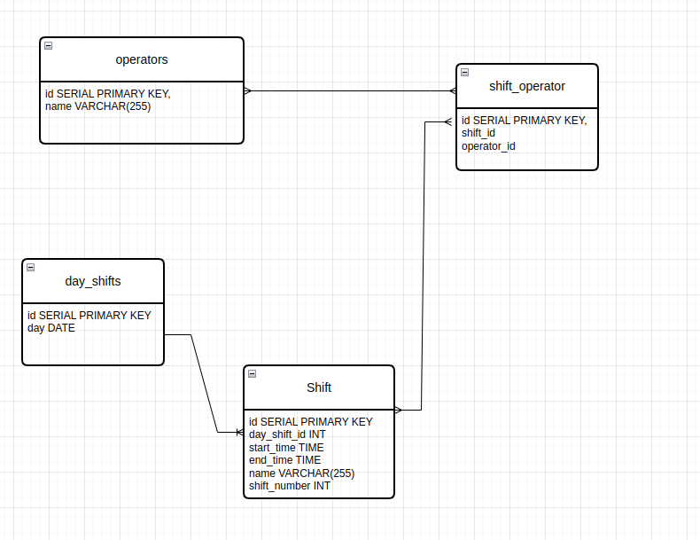

Json request
If you make the request with 3 space it return bad request.

